Azure 201 Project

Task 1:

Write a template to create a Storage Account with SKU restrictions, encryption enabled and allow https access only.

Step 1: Go to azure portal [www.portal.azure.com](http://www.portal.azure.com) and check if you have the subscription. If not, go to create a subscription and enter details. You will get 1 year free credits.

Step 2: Open cloud shell and create a storage if you don’t have one.

Step 3: Go to create a new resource. Search for “template deployment” in the market place. Select the template deployment and click on “create”.

Step 4: Select the “build you own template in the editor”.

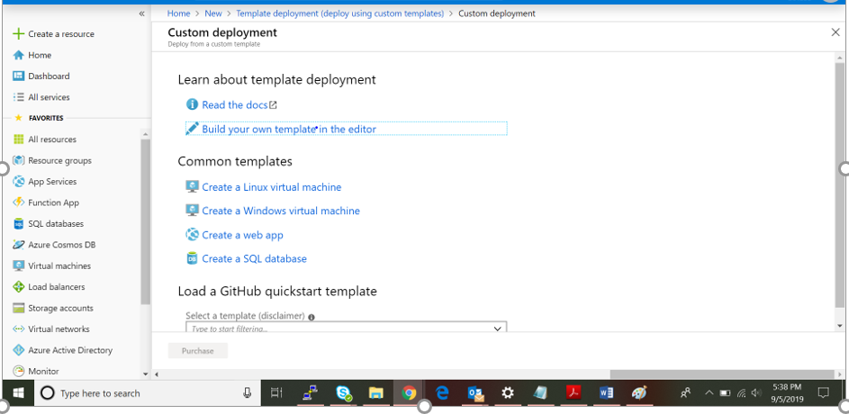

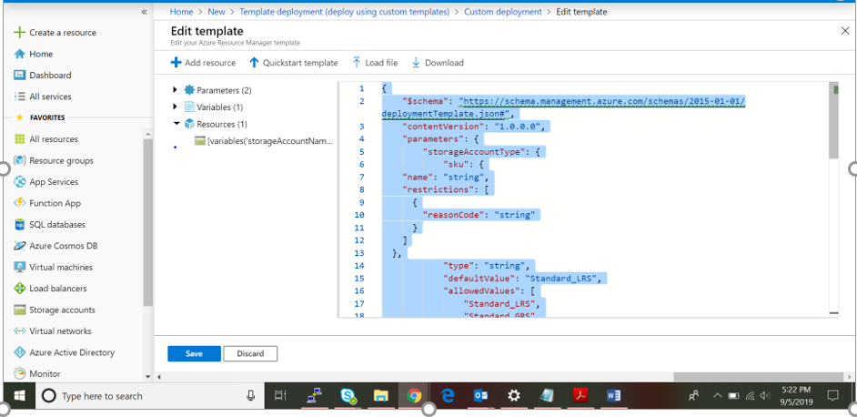Paste the following contents of arm-1.txt in the editor. Save the contents and click on purchase.

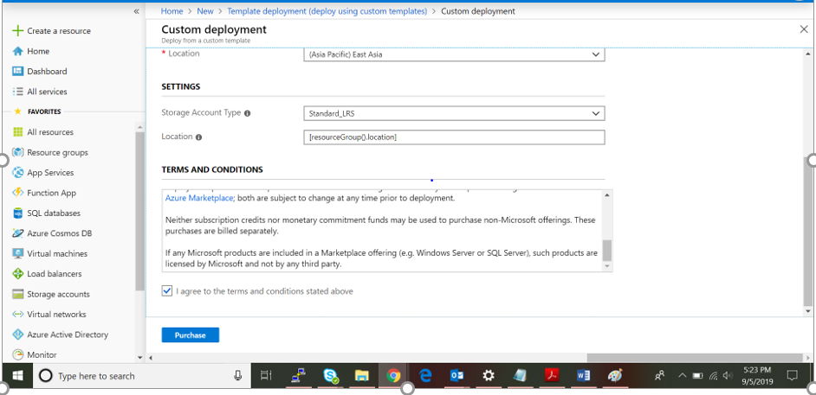

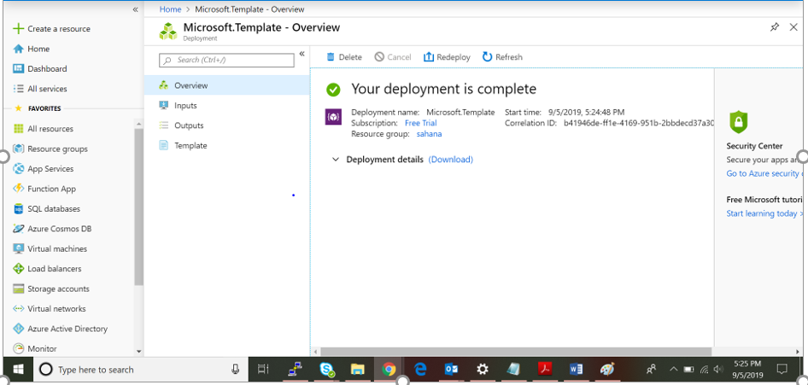

Once the deployment is complete, we get this page.

Step 5: To add the SKU restrictions, the arm template is in the file arm-2.txt.

Open cloud shell and run the following command.

az policy definition create --name 'allowed-storageaccount-sku' --display-name 'Allowed storage account SKUs' --description 'This policy enables you to specify a set of storage account SKUs that your organization can deploy.' --rules 'https://raw.githubusercontent.com/Azure/azure-policy/master/samples/built-in-policy/allowed-storageaccount-sku/azurepolicy.rules.json' --params 'https://raw.githubusercontent.com/Azure/azure-policy/master/samples/built-in-policy/allowed-storageaccount-sku/azurepolicy.parameters.json' --mode All

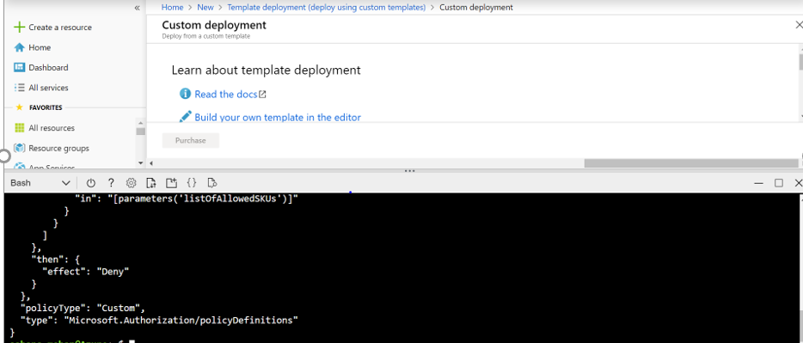

This updates the storage account with the SKU restrictions.

Step 6: To allow only https access.

The arm template to allow only https access is in the file arm-3.txt.

Run the following command in the cloud shell.

az policy definition create --name 'https-traffic-only' --display-name 'Ensure https traffic only for storage account' --description 'Ensure https traffic only for storage account' --rules 'https://raw.githubusercontent.com/Azure/azure-policy/master/samples/Storage/https-traffic-only/azurepolicy.rules.json' --params 'https://raw.githubusercontent.com/Azure/azure-policy/master/samples/Storage/https-traffic-only/azurepolicy.parameters.json' --mode All

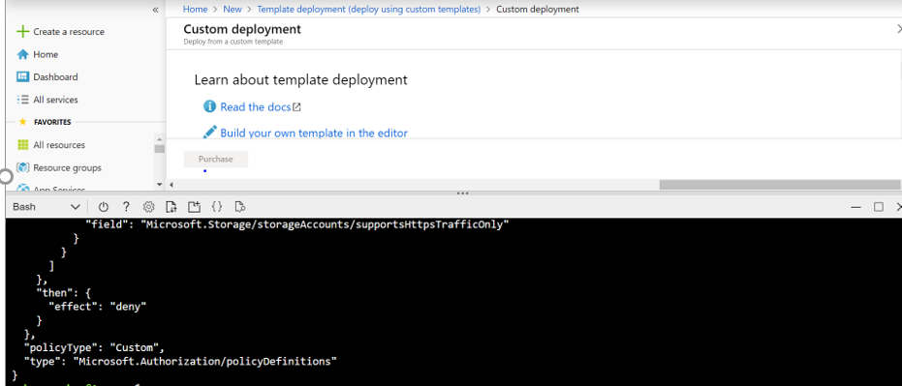

Step 7: To allow encryption.

The arm template is in arm-4.txt file.

Run the following command in the cloud shell.

az policy definition create --name 'storage-account-file-encryption' --display-name 'Ensure storage file encryption' --description 'Ensures file encryption for storage accounts' --rules 'https://raw.githubusercontent.com/Azure/azure-policy/master/samples/Storage/storage-account-file-encryption/azurepolicy.rules.json' --params 'https://raw.githubusercontent.com/Azure/azure-policy/master/samples/Storage/storage-account-file-encryption/azurepolicy.parameters.json' --mode All

